Nicholas Lichtsinn

IST659 Week 6 Lab

5/14/2021

Part 1 – Filling our Tables with Data

First VidCast

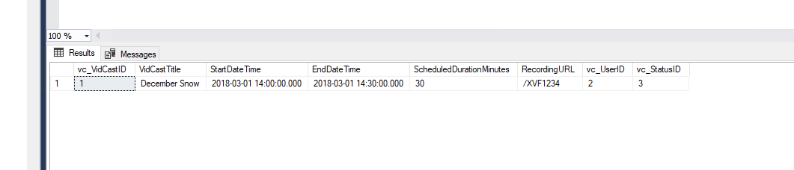

Saul’s First VidCast

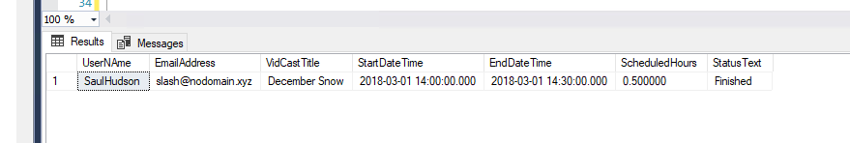

Update a User

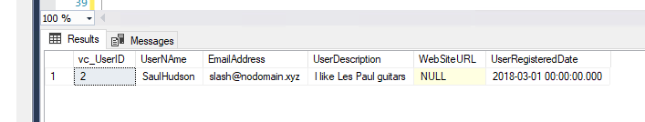

No More ‘On Time’

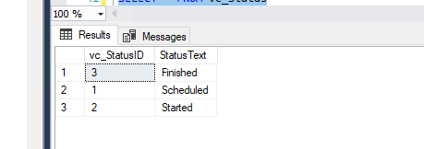

Part 2 – Putting All Together

Tags

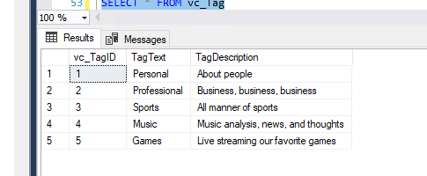

Users

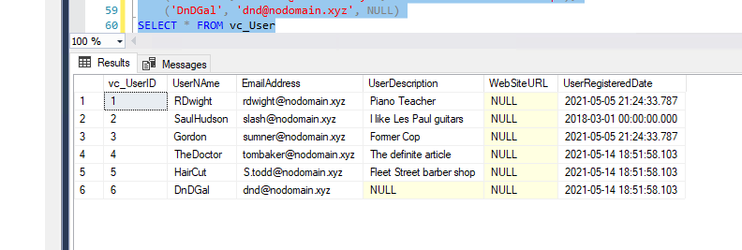

User Tag List

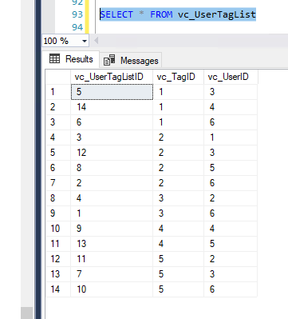

User Tags Report

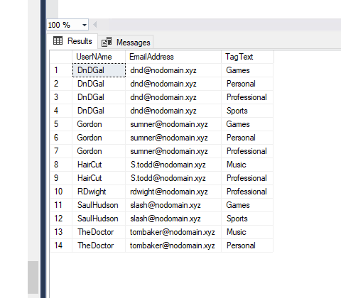

SQL Query Text

INSERT INTO vc_Status (StatusText)

values ('Scheduled')

INSERT INTO vc_Status (StatusText)

values ('Started'), ('Finished'), ('On Time')

SELECT * FROM vc_Status

select * from vc_user where UserName = 'SaulHudson'

select * from vc_status where StatusText = 'Finished'

insert into vc_VidCast

(VidCastTitle, StartDateTime, EndDateTime, ScheduledDurationMinutes, RecordingURL, vc_UserID, vc_StatusID)

values

('December Snow', '3/1/2018 14:00', '3/1/2018 14:30', 30, '/XVF1234', 2, 3)

select * from vc_VidCast

select

vc_User.UserNAme

, vc_user.EmailAddress

, vc_VidCast.VidCastTitle

, vc_VidCast.StartDateTime

, vc_VidCast.EndDateTime

, vc_VidCast.ScheduledDurationMinutes / 60.0 as ScheduledHours

, vc_Status.StatusText

FROM vc_VidCast

JOIN vc_User ON vc_VidCast.vc_UserID = vc_User.vc_UserID

JOIN vc_Status ON vc_VidCast.vc_StatusID = vc_Status.vc_StatusID

WHERE vc_User.UserNAme = 'SaulHudson'

ORDER BY vc_VidCast.StartDateTime

UPDATE vc_User SET UserRegisteredDate = '3/1/2018' WHERE UserNAme = 'SaulHudson'

SELECT * FROM vc_User WHERE UserNAme = 'SaulHudson'

SELECT * FROM vc_Status

DELETE vc_Status WHERE StatusText = 'On Time'

SELECT * FROM vc_Status

SELECT * FROM vc_Tag

INSERT INTO vc_Tag (TagText, TagDescription)

VALUES

('Personal', 'About people'),

('Professional', 'Business, business, business'),

('Sports', 'All manner of sports'),

('Music', 'Music analysis, news, and thoughts'),

('Games', 'Live streaming our favorite games')

SELECT * FROM vc_Tag

INSERT INTO vc_User (UserNAme, EmailAddress, UserDescription)

VALUES

('TheDoctor', 'tombaker@nodomain.xyz', 'The definite article'),

('HairCut', 'S.todd@nodomain.xyz', 'Fleet Street barber shop'),

('DnDGal', 'dnd@nodomain.xyz', NULL)

SELECT * FROM vc_User

INSERT INTO vc_UserTagList (vc_UserID, vc_TagID)

VALUES

((SELECT vc_UserID FROM vc_User WHERE UserName='DnDGal'),

(SELECT vc_TagID FROM vc_Tag WHERE TagText='Sports')),

((SELECT vc_UserID FROM vc_User WHERE UserName='DnDGal'),

(SELECT vc_TagID FROM vc_Tag WHERE TagText='Professional')),

((SELECT vc_UserID FROM vc_User WHERE UserName='RDwight'),

(SELECT vc_TagID FROM vc_Tag WHERE TagText='Professional')),

((SELECT vc_UserID FROM vc_User WHERE UserName='SaulHudson'),

(SELECT vc_TagID FROM vc_Tag WHERE TagText='Sports')),

((SELECT vc_UserID FROM vc_User WHERE UserName='Gordon'),

(SELECT vc_TagID FROM vc_Tag WHERE TagText='Personal')),

((SELECT vc_UserID FROM vc_User WHERE UserName='DnDGal'),

(SELECT vc_TagID FROM vc_Tag WHERE TagText='Personal')),

((SELECT vc_UserID FROM vc_User WHERE UserName='Gordon'),

(SELECT vc_TagID FROM vc_Tag WHERE TagText='Games')),

((SELECT vc_UserID FROM vc_User WHERE UserName='HairCut'),

(SELECT vc_TagID FROM vc_Tag WHERE TagText='Professional')),

((SELECT vc_UserID FROM vc_User WHERE UserName='TheDoctor'),

(SELECT vc_TagID FROM vc_Tag WHERE TagText='Music')),

((SELECT vc_UserID FROM vc_User WHERE UserName='DnDGal'),

(SELECT vc_TagID FROM vc_Tag WHERE TagText='Games')),

((SELECT vc_UserID FROM vc_User WHERE UserName='SaulHudson'),

(SELECT vc_TagID FROM vc_Tag WHERE TagText='Games')),

((SELECT vc_UserID FROM vc_User WHERE UserName='Gordon'),

(SELECT vc_TagID FROM vc_Tag WHERE TagText='Professional')),

((SELECT vc_UserID FROM vc_User WHERE UserName='HairCut'),

(SELECT vc_TagID FROM vc_Tag WHERE TagText='Music')),

((SELECT vc_UserID FROM vc_User WHERE UserName='TheDoctor'),

(SELECT vc_TagID FROM vc_Tag WHERE TagText='Personal'))

SELECT * FROM vc_UserTagList

SELECT

vc_user.UserNAme,

vc_user.EmailAddress,

vc_Tag.TagText

FROM

vc_User

JOIN vc_UserTagList ON vc_User.vc_UserID = vc_UserTagList.vc_UserID

JOIN vc_Tag ON vc_UserTagList.vc_TagID = vc_Tag.vc_TagID

ORDER BY vc_User.UserNAme, vc_Tag.TagText